EXT api sonar setup
- Go to sonar url
- Login Sonar url using below details and other details are given below
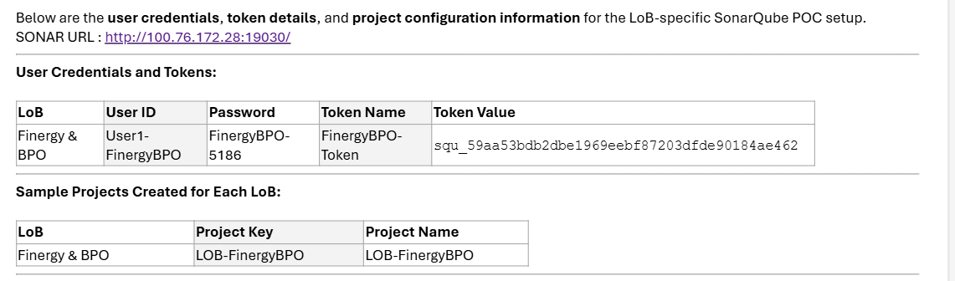
- Click on create project 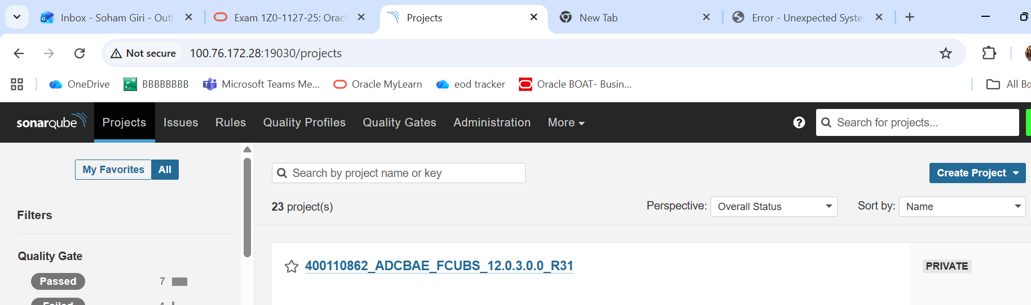
- Click project >manually (give project name ,click setup ,after setting up token will be shown in screen
- Go to sonar shell script in the workspace
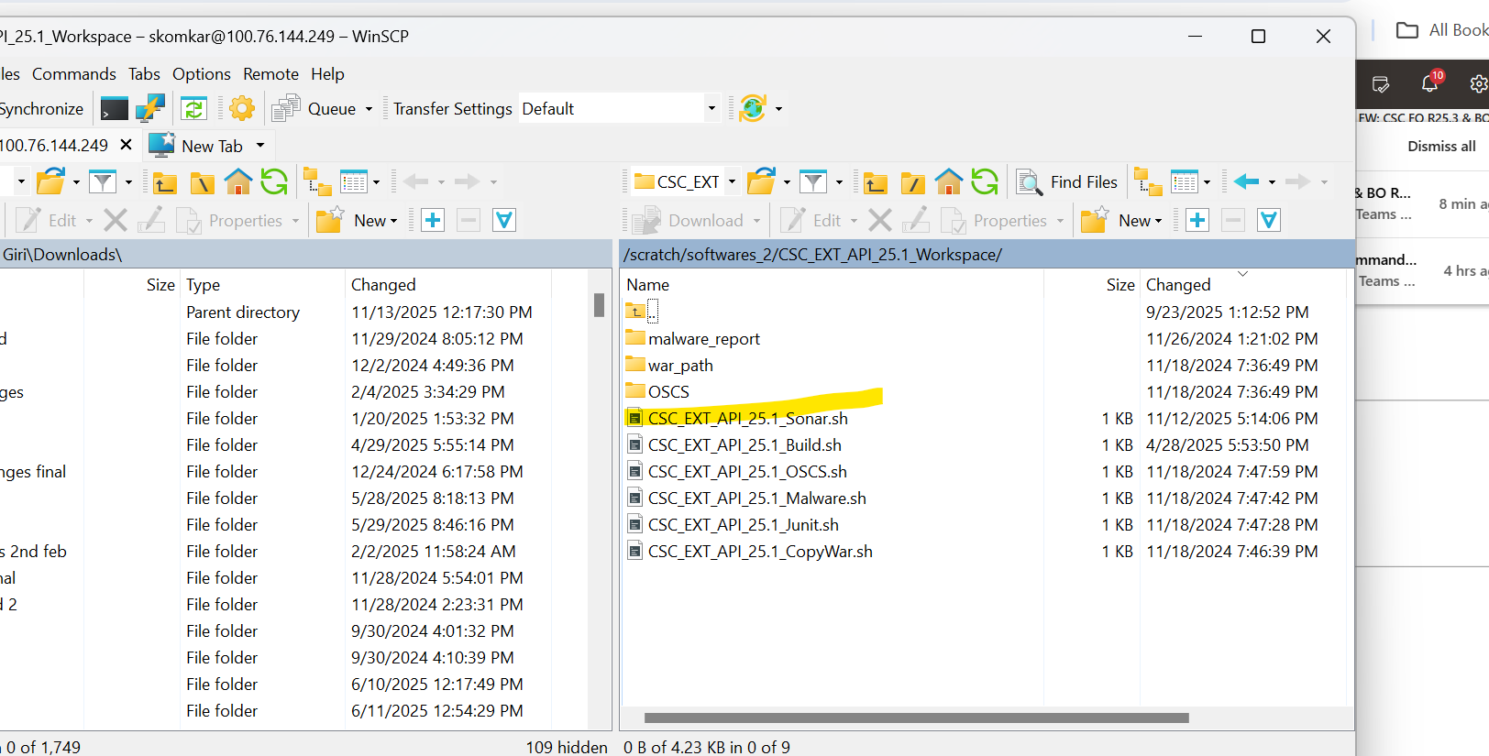
- Open the sh file and replace below things has to be replaced,example given below
mvn org.sonarsource.scanner.maven:sonar-maven-plugin:3.9.1.2184:sonar \
-Dsonar.projectKey=PSD.JAPAC.CSC.FO.EXT.API.25.1 \
-Dsonar.host.url=http://100.76.172.28:19030 \ (Sonar url)
-Dsonar.ojaudit.enabled=false \
-Dsonar.login=sqp_6c5e04a2bf67ba703ff9e81f8a8f3402a39851f1 \ (this token will bw generated after setting up project)
-Dmaven.test.skip=true \
-Dmaven.repo.local=/scratch/Build/m2/repository/ORM_MAVEN_REPO_V1/repository \
-o
- Run sh file in putty build should be successful
- Check sonar dashboard for respective project the date should be updated for code coverage
- To download the report ,click on more at the top bar

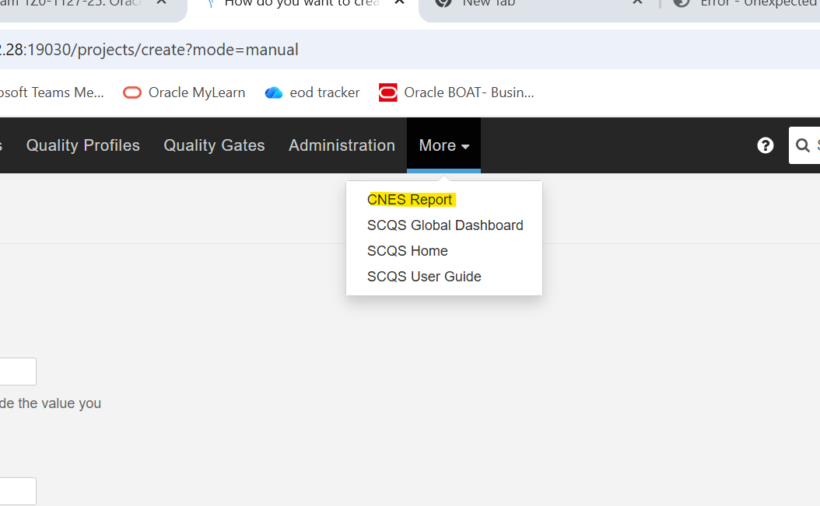

10.click on cnes report>select the project > all other options will be as it is ,only check and enable xlsx report

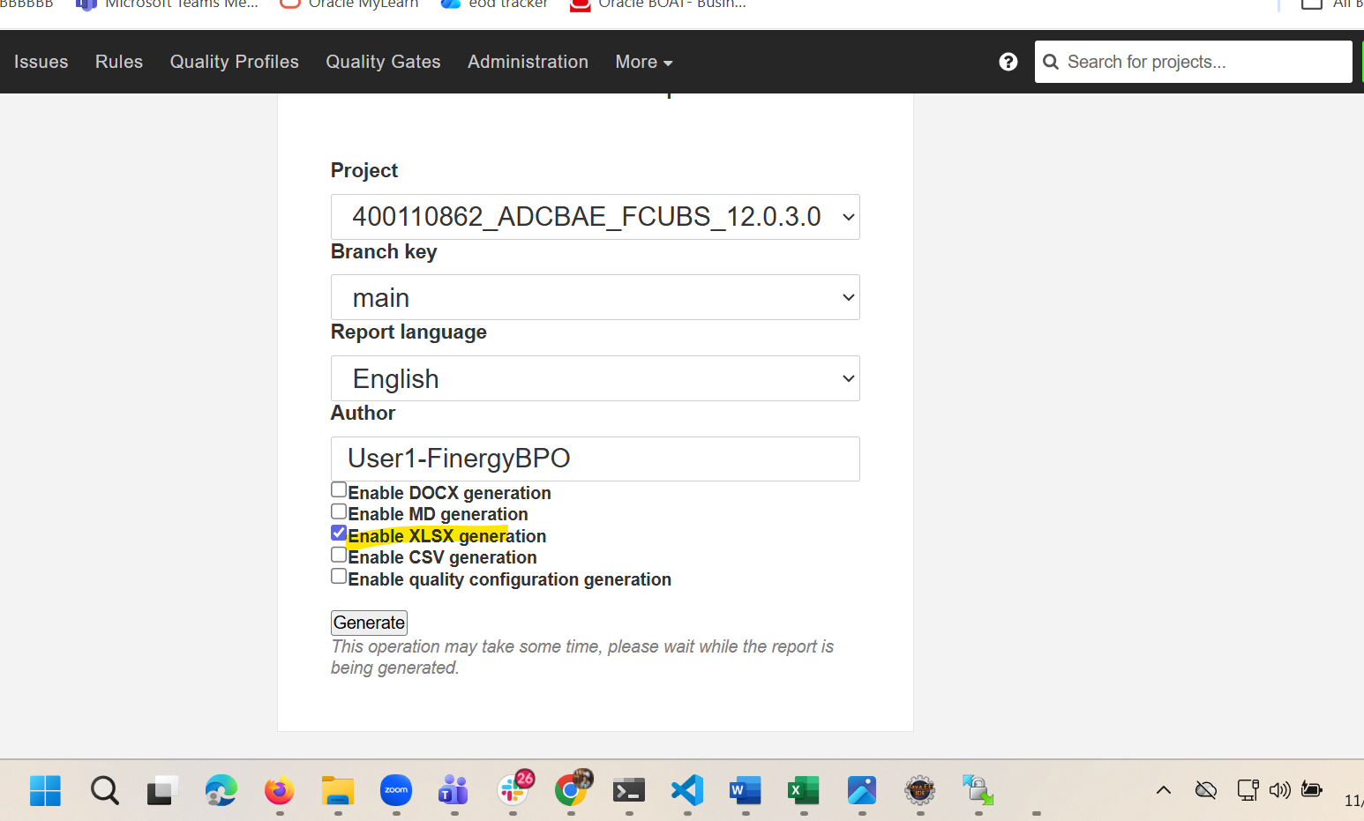

Click on Generate Zip file should be downloaded.

